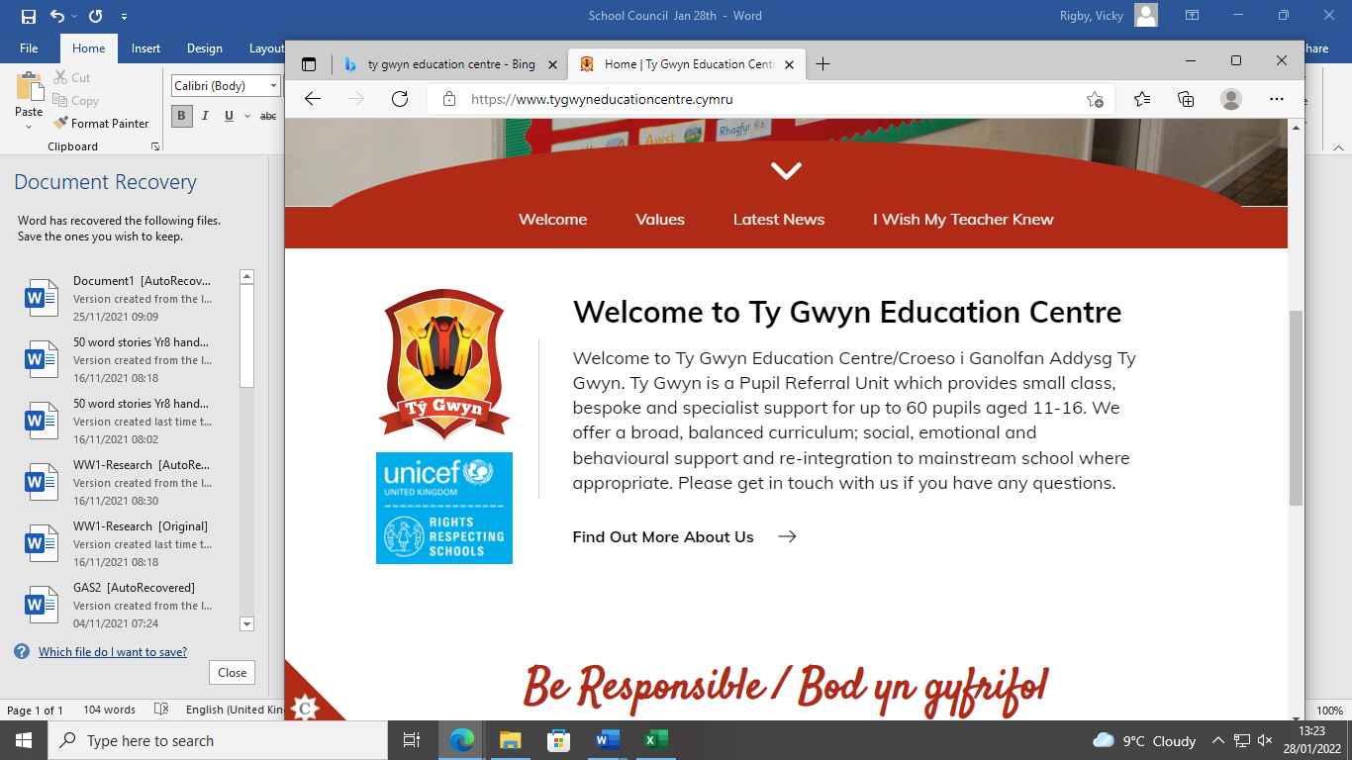


Meeting: 30th September 2026
Agenda

- Welcome back
- Rewards and incentives
- Safeguarding
- School bell
- Food taster day
- Rights Respecting Update: Harvest collection
- AOB

Pupils present:
LB, CHH, CR, LBY, KB, LC, RJ, TR, ME

Welcome back
Our Student Council welcomes our new Year 7 members and have shared our calendar of upcoming events for this term with an introduction to our Rights Respecting work. Students have had a positive start to the term and like the celebration assemblies on a Friday.

Rewards and Incentives
Students would like to have the bouncy castles as part of the Halloween activities at the end of term. Students would also like a breakfast at the end of term in their form families.

Safeguarding
No issues reported.

School bell
Students have requested that the bell is turned off again through the day as it sounds too loud.

School menu
Students have asked for an update on the changing menu as menu has been the same for quite some time.

Tasting different foods
Students would like to try different fruits as they really enjoy the melon at lunch time.

Rights Respecting Update: Harvest Collection
As part of our social action as part of our RRS work, staff and students to organise a collection of tinned / dry foods for a local food bank or families in need. Students will design a poster and help organise the parcels and deliver to the local food bank.

Updates will be posted on the noticeboard
Article #12 the right to have your views heard and aken seriously

